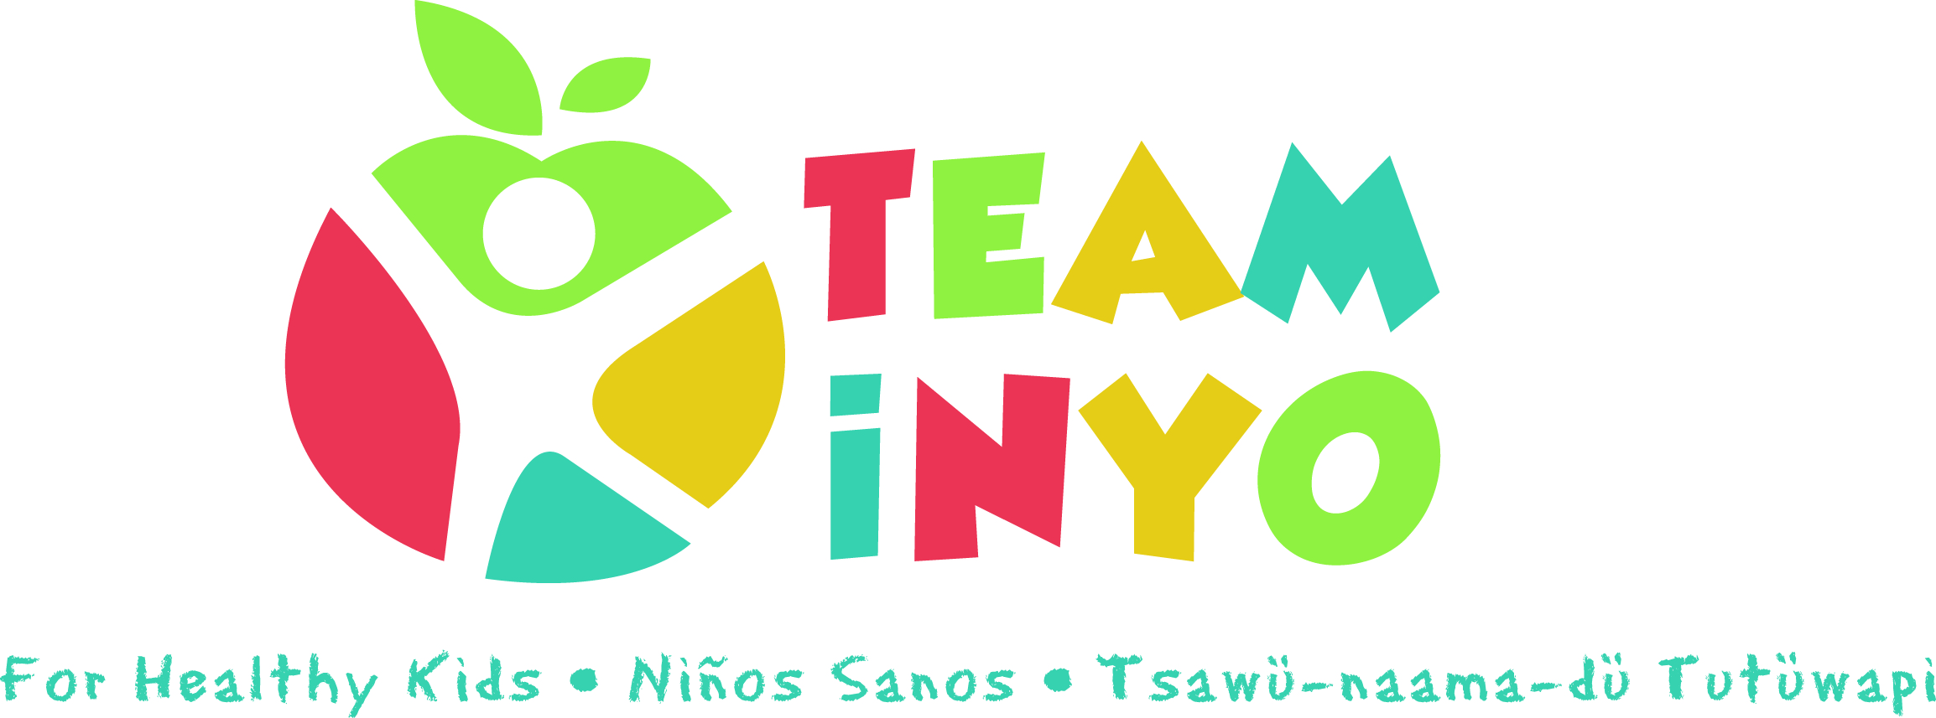
Minutes
November 5th, 2020
Via Zoom
- In Attendance: Micaela Muro (HHS Prevention), Amy Weurdig (Child Support Services), Tiana Morrison (Bishop Elementary), Josie Rogers (Bishop Paiute Tribe), April Eagan (HHS Prevention), Karen Harrison (Kern Regional), Grace Voorheis (HHS Prevention), Eryn Clark (HHS Prevention), Carrie Brown (BIEC), Aaron Hutton (CSS-CalFresh), Jenna McCarthy (CSS-CalFresH), Leticia Gonzalez (Toiyabe/BTYC), Tim Villanueva (HHS Prevention)

*Guest Speaker Elizabeth Navarro with Smile California Re-scheduled

- Challenge Check-in/Updates:
- Micaela gave update on the Virtual Healthy Holiday Challenge via the Team Inyo Facebook. We had to change using hashtags to submitting photos to us since some private profiles will not show if using the hashtags alone. The week-long idea at the end of the month got changed to month-long to give folks a bigger window to participate and to avoid making extra work for the group to come up with activities for the one week when we already have a lot going on to be able to promote.
- Also gave update on the website expansion for agency information and centralization of events via our calendar and announcements via community bulletin board under “About Us”. Asked the group to submit any updates/program info to add in.
- Discovery Tool App Update: Micaela will follow-up with Anne Banchoff from Stanford to see what/if results submitted by the end of October resulted in any project we can work towards.
- April gave a friendly reminder about our in-person outreach via the Team Inyo for Healthy Kids Health Fair. This is put on every 2nd Saturday of the month from 9AM-NOON at Millpond. Partners interested in signing families up and/or participating in boothing there with an activity specific to their program can reach Tim Villanueva at tvillanueva@inyocounty.us and have access to the share drive with sign-ups, paperwork, and info here:

https://drive.google.com/drive/folders/1GS5d4osExJ94zTlu0ftSsGHG-sKO_Y4g?usp=sharing
- Feedback from last time Team Inyo did a virtual challenge in May – they had 70 participate in the FB group, 12 completed documentation, not everyone picked up their prizes, how to make documentation easier?
- Micaela highlighted South County schools wanting some kind of virtual and/or in-person cooking classes again. Core project group will brain-storm separately to offer a collaborative series like before. Otherwise, some ideas to offer schools and families for cooking and nutrition:
- League of Kitchens recommended for virtual cooking classes
- Bishop Indian Education Center cooking classes with Bishop Food Soverienty
- Josie Rogers offered a cooking class
- Food preservers preregistered cooking class
- FNEP 4H curriculum cooking
- Round-Table:
- April Eagan shared about a Substance Use Disorder Virtual Summit on December 2nd
- Eryn Clark shared about The Great American Smoke Out (GASO)- cessation promotion 3rd Thur of November which will be Nov 19th (The virtual event will take place15-21st)
- 15 min of PA and in honor of someone lost or needing to quit
- Through Tobacco Free Eastern Sierra Facebook
- Grace Voorheis, Dietician from WIC, announced about her Virtual Prenatal Breastfeeding 101 class on Saturday, December 5th, from 9-11AM and plans to be hosting one quarterly in liue of no longer having the NEST at NIH.
- Karen Harrison will be hosting a FREE Kids Zumba THIS Saturday, November 21st, from 9-9:30AM via Zoom *also cannot participate n any in-person work-related activities.
- Jenna McCarthy reminded us about their Quarantine Kitchen which is weekly on Thursdays on their Community Service Solutions Facebook
- cooking demo for adults/Wellness Wednesdays/Fitness Friday possibility
- Looking to create Mono County resource similar to Team Inyo and would like any virtual services to be added to their calendar-please e-mail: chelseabertramcss@gmail.com
- Gave upate about Brooke Ross no longer being a part of Snap-Ed, and introduced Autumn Tyerman as the new specialist alongside Aaron Hutton specifically in Bishop, as they also cover Alpine and Mono and are looking to expand to us as well.
- Tim Villanueva reminded/gave info on the Team Resource Health Fair and about this Mentor program Take and Bake Drive-Thru event at the end of October.
- Josie Rogers told the group abouto November being Native American Heritage Month- not much going on/just had vape prevention event with Eryn Clark
- tanf and ovcdc specifiy on flyers whether Native American preferene or community-wide event.
- Tianna Morrison - Lunch bunch group on Tuesdays/socoemotional connection participation via school website to encourage submitting photos to the team inyo challenge.
- Carrie Brown – Bishop Tribal Youth Council meets on Join.me every other Sunday at 4PM
- Bishop Tribal Youth November 8th and 22nd
- Council meeting 6th-12th/fundraising to sponsor community events-trash clean-up event virtually for $100 gift card.
- KBPT@bishoppaiute.org for announcing activities/IT at BPT
- Native American Heritage Month Drive-Thru event on the 23rd 5-7PM
- Fall Gathering YUUWANO – December 7th
- And winter gahering drive-thru event TBD

*CONGRATULATIONS to the new Miss Bishop Paiute Tribe Princess Jazymn Dondero*

- Next Meeting Date and Location: Our next meeting will be from 10AM-11AM, December 3rd via ZOOM.

