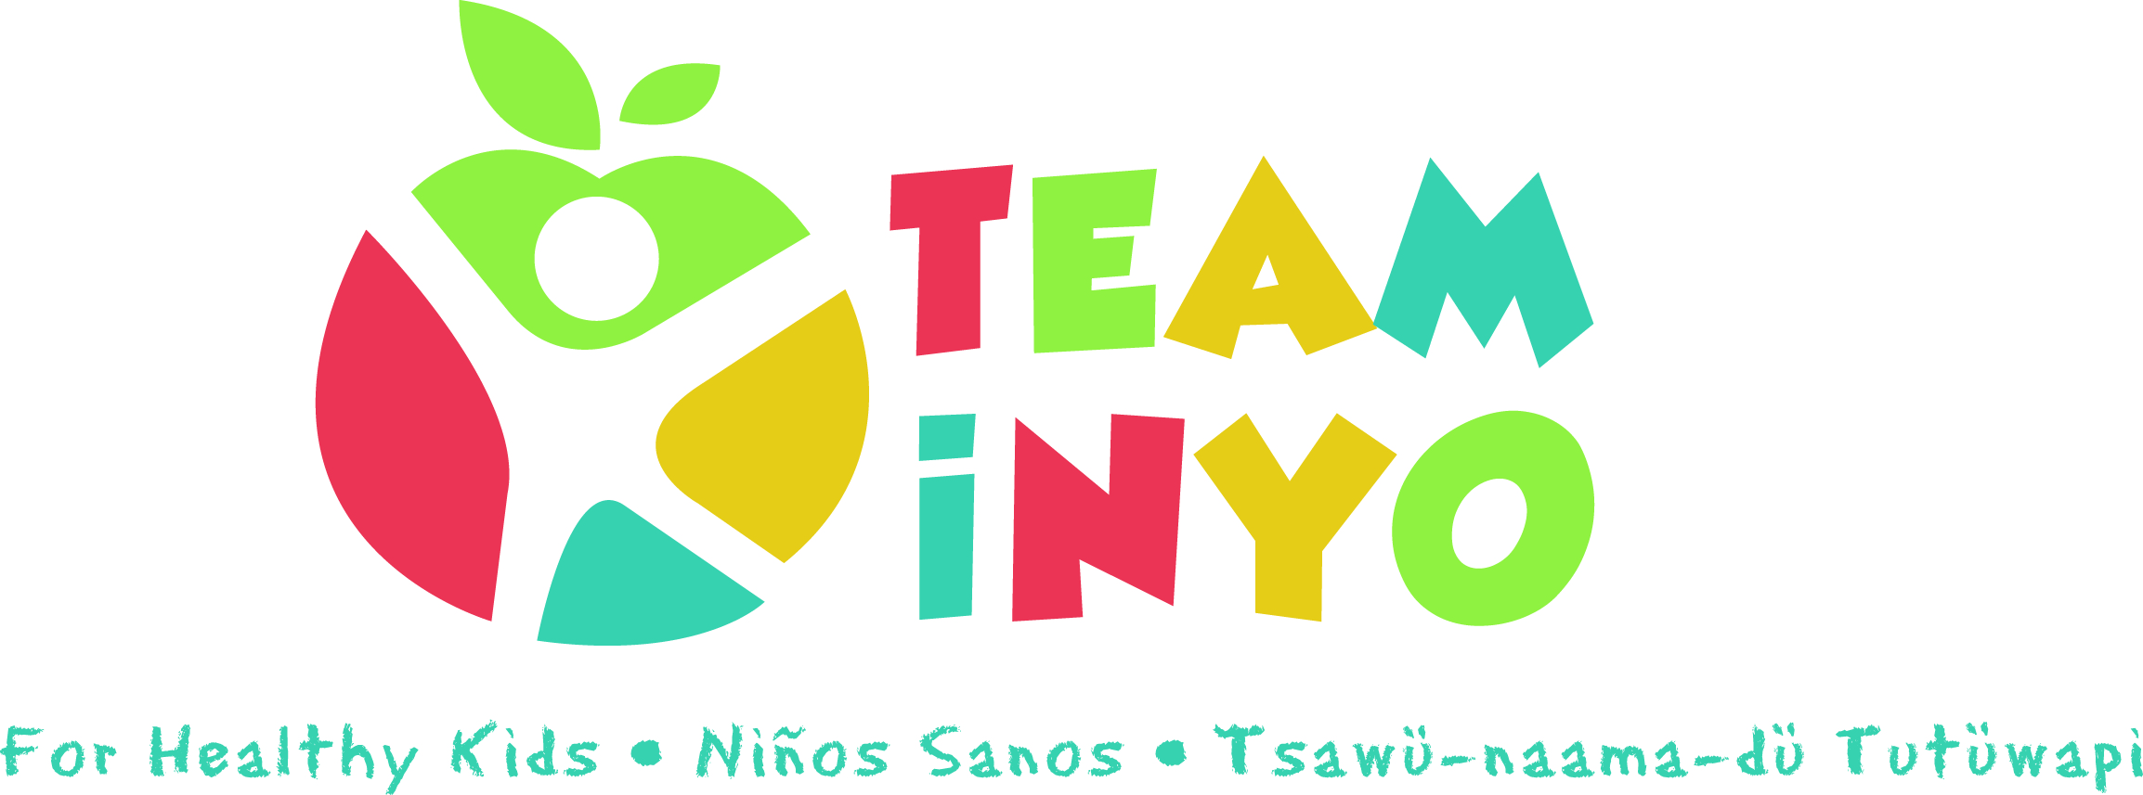
Meeting Agenda
November 5th 2020
10:00-11:00am
Via Zoom
- Introductions 10:00 am
- Guest Speaker Elizabeth Navarro with Smile California 10:15 am
- Challenge Check-in and Updates /Round Table 10:45 am

Action Step | Person Responsible | Due Date/Check -in

