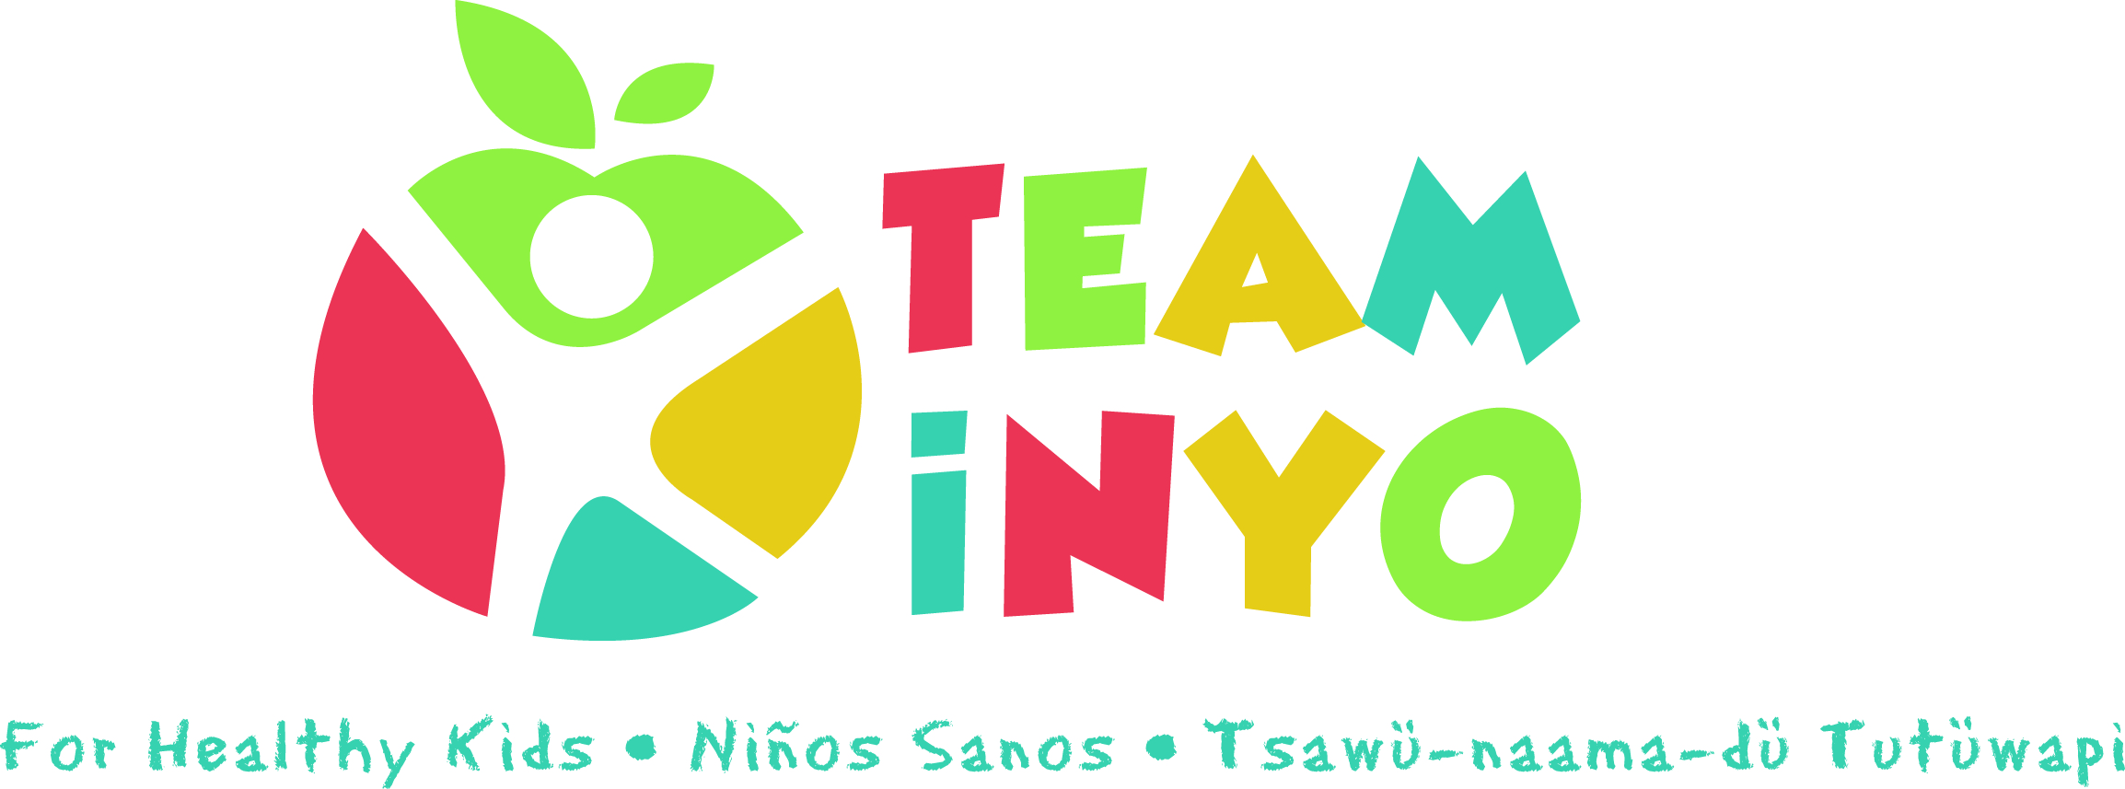
Minutes
February 13, 2020
Toiyabe Indian Health Project, TIHP Main Conference Room
- In attendance: TimVillanueva (HHS Prevention), Gaylene Kinzy (Food Sovereignty Program), Anna Huston (IMACA HeadStart), June Piper (ROSS Program), Suzanne Rizo (Child Support Services), Marjorie N.(Toiyabe Prevention), Muro (HHS Prevention), Karen Harrison (Kern Regional), Hannah Dykstra (Tribe Food Sovereignty)

- News from the group:
  - Previous News:
    - Give Kids A Smile Dental Screening Event February 7th
    - Pruning workshop with Food Sovereignty Program February 21st
    - Family Fun Day Planning February 21st
    - 5th Graders Food Waste Presentation February 20th
    - Family Cook Night at Bishop Indian Head Start February 25th
    - Toiyabe DEEP Program starting the last week of February 26th – April 1st
    - Lone Pine Youth Co Fun Run cancelled
  - Upcoming News:
- Bishop High Youth Co Fun Run TOMORROW February 29th
- Pruning workshop with Food Sovereignty Program March 6th
- Family Fun Day on May 9th
- Rethink Your Drink Campaign May 13th
- Health Fair in May at Toiyabe
- Bishop Elm St. Fun Run in April
- Free Seed Library April 6th

- Goals and Projects for 2020:
  - Gardening maintenance through Summer will be too hard. Maybe integrate and piggy-back on programs already happening:
- Thursday Market garden tours
- After school program at HeadStart
- JKBS and Office of Education have garden beds

  - Spring Relay Run & Health Fair TOMORROW February 29th there will be a waiver for kids to participate in the relay race. Free event for anyone to attend.
  - School Field Day suggested for after lunch time and as part of the CATCH school launch. Still pending and might be pushed back to next year.
  - Other Events/Planning
- The Seed Library at the Cultural Center will allow 5 seeds to be checked out on Monday, April 6th from 9am-4pm.
- There is also a 5th grader workshop for seeds
- Team Inyo members will be volunteering at least 1x/month at the Thursday Night Markets to represent Team Inyo for Healthy Kids with an activity booth and there is a shared Google Calendar to sign-up.
- WIC is providing a breastfeeding support Wednesdays at lunch starting mid-March.
- Opioid or Education Summit mentioned to be in May and to check on dates since there are so many events going on this month.
- Arts Council offering Community READS which offers cooking, culture, and coming together.

- Next Meeting Date and Location: Our next meeting will be from 3pm-4:30pm on April 2nd at Toiyabe Indian Health Project, TIHP Main Conference Room.

