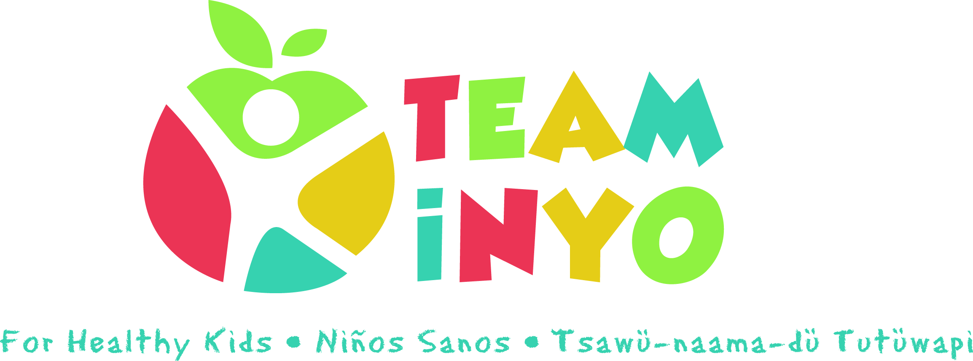
Minutes
October 1st, 2020
Via Zoom
- In Attendance: Micaela Muro (HHS Prevention), Amy Weurdig (Child Support Services), Tiana Morrison (Bishop Elementary), Josie Rogers (Bishop Paiute Tribe), April Eagan (HHS Prevention), Brooke Ross (Snap-Ed), Karen Harrison (Kern Regional), Grace Voorheis (HHS Prevention)

- Virtual Outreach during Covid19:

- Micaela gave background on Team Inyo for Healthy Kids projects and impact on community (I.e. Walk to School Day, water fountains, school cooking classes).
- Brainstormed doing a virtual challenge through Team Inyo – discussed rewards, what worked last time, timeframe, focus
- Some of the ideas were focusing on nutrition and healthy Halloween treats, broadening it to wellness and offering activities that organizations are already doing, such as the webpage on wellness the school counselor is offering, and “scavenger hunt” card
- Brooke shared that she does Wellness Wednesdays and leads activities for different age groups at the elementary school
- Feedback from last time Team Inyo did a virtual challenge in May – they had 70 participate in the FB group, 12 completed documentation, not everyone picked up their prizes, how to make documentation easier?
- Suggestion to do a challenge like Team Inyo Week from the past and have people post pics showing what wellness activity they are doing and tag Team Inyo
- Suggestion to limit to one week
- Suggestion to do something ongoing to promote healthy habits over the long-term
- Link website to FB, link school website to Team Inyo calendar, post activity ideas from different organizations on the calendar
- Micaela will work with individual agencies to develop the challenge
- Decided a one-week challenge once a month at the end of the month through the holidays and call it “Healthy Holiday Challenge”
- First one will be the last week of OctoberJosie shared they have a workshop called Healthy Food Choices coming up October 7 that could be included

- Next Steps:

- Trial virtual “Healthy Holiday Challenge”
- Partners to promote using #teaminyoforhealthykids and @teaminyoforhealthykids with clients during the month to be entered into raffle the last Thur. of the month if participating in any community events
- Discovery Tool Re-visit
- Fairgrounds Trunk or Treat happening October 31 - big event

- Next Meeting Date and Location: Our next meeting will be from 10AM-11AM, November 5th via ZOOM.

