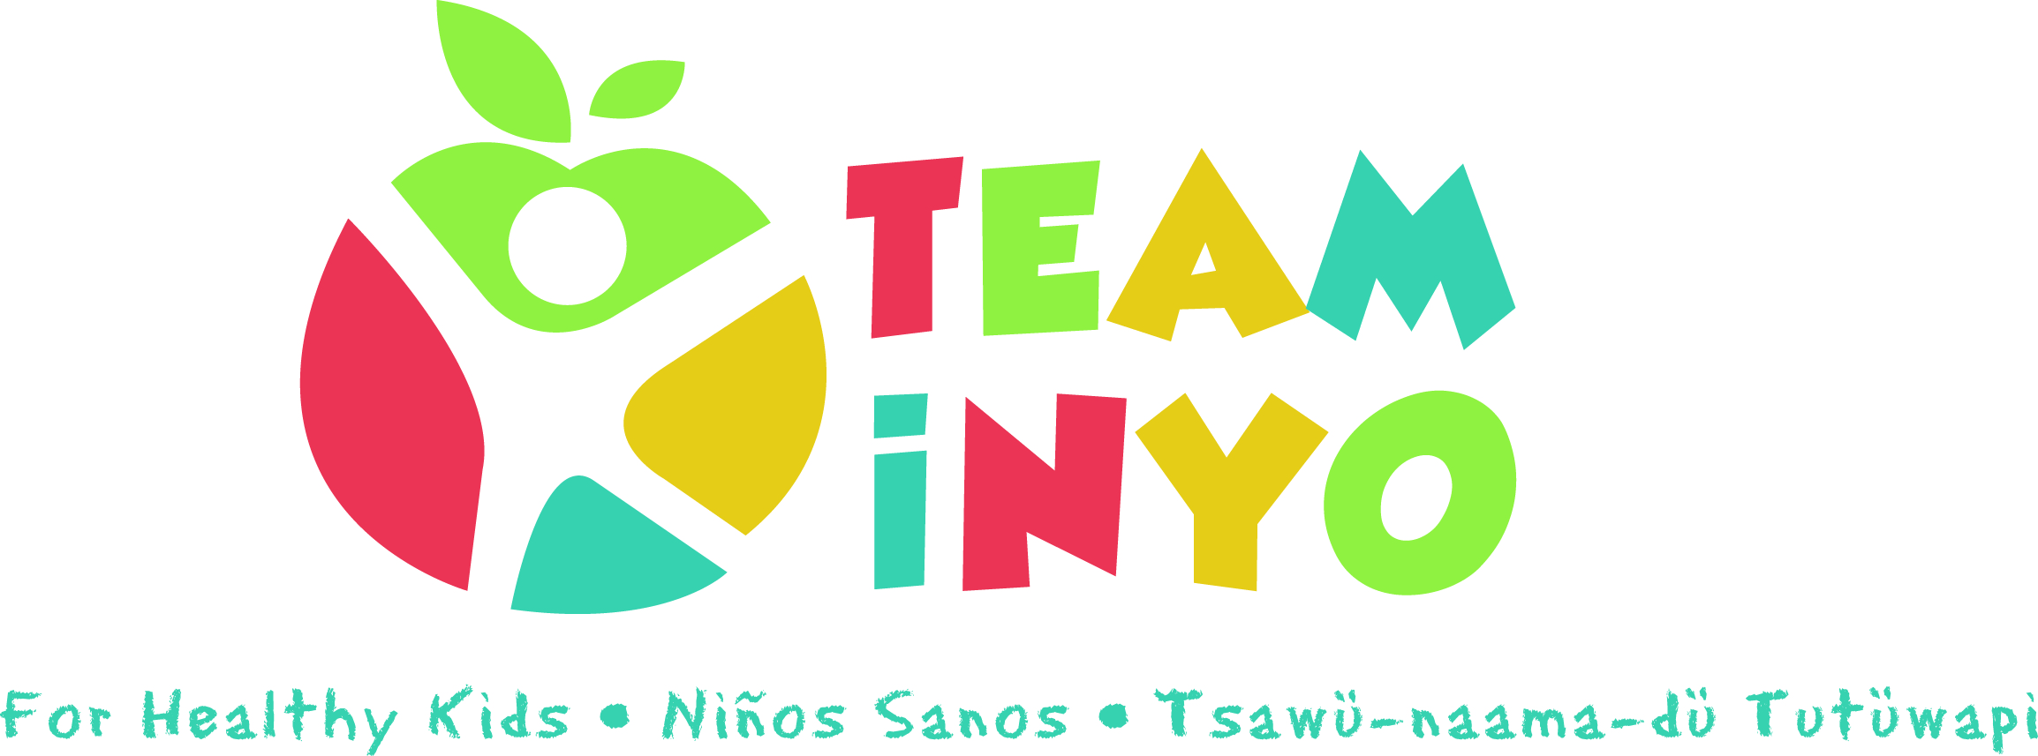
Minutes
January 23, 2020
Toiyabe Indian Health Project, TIHP Main Conference Room
- In attendance: Brooke Ross (SNAP-Ed), TimVillanueva (HHS Prevention), April Eagan (HHS WIC), Marissa Whitney (HHS Nurse), Shannon Beasley (Toiyabe Prevention), Emily Faircloth (HHS Prevention), Micaela Muro (HHS Prevention), Karen Harrison (Kern Regional), Hannah Dykstra (Tribe Food Sovereignty)

- News from the group:
  - Previous News:
    - There was a very informative food waste presentation given by Hannah.
  - Upcoming News:
- Toiyabe DEEP Program starting the last week of February 26th – April 1st
- Family Fun Day on May 9th (planning on Friday, February 21st/contact Karen)
- Rethink Your Drink Campaign May 13th
- Health Fair in May at Toiyabe
- School Field Day by end of school year

- Goals and Projects for 2020:
  - Stencils – There was a few sheets of paper passed around the room to see which stencil kits would be the best for Team Inyo.
  - Dental screening on Feb. 7th. It is open to everyone although it is more geared toward families in need for dental care.
  - Spring Relay Run & Health Fair; there will be a waiver for kids to participate in the relay race. Both are free events for anyone to attend.
    - Feb. 22nd in Lone Pine – located at the Lone Pine High School
    - Feb. 29th in Bishop – located at the Bishop High School
  - Farmer’s Market – Using stencils or chalk to make fun activities for the kids to get parents to shop locally. Farmer’s markets are Thursdays in the evening time when the season begins.
  - Kids working in the garden?
    - Gardening for kids after school at the school gardens & more!
      - Gretchen from Bishop Elementary School is on board for 5th graders to have their own garden beds. Although there would need to be someone there in the Summer time to maintain the gardens.
      - The 2nd graders have started their own plots between the kindergarten and 1st grade buildings.
      - The Head Start offers Farm to School program
      - Would like to inquire with Amy about Masters Gardeners
      - Would like to inquire with NIH about garden beds through health plans.
      - Connect with: a) the 350 Group (Nancy H.) about elderly community service in regards to garden maintenance
b) Food Sovereignty and workshops at Cultural Center
c) The Native Plan Society workshops at White Mtn Research
d) Follow-up with the Toiyabe Acorns Grant
  - Gardening classes that are no cost for people to learn how to garden and grow their own vegetables, fruit, and/or herbs. Can Team Inyo sponsor a plot?
  - Park-Rx – Similar outline that the Bay Area has/invite ESSRP to partner
- Ask City of Bishop, Parks and Rec, and Conservancy, BLM, Forest Service etc. to throw events
  - Family Fun Day is on May 9th. There will be a meeting on February 21st at 3pm. It will be about planning, information, and new requirements for family fun day.
  - DEEP Program starting the last week of February 26th – April 1st
  - Green Rx will most likely be back this summer!!
- Next Meeting Date and Location: Our next meeting will be from 3pm-4:30pm on February 13th at Toiyabe Indian Health Project, TIHP Main Conference Room.

