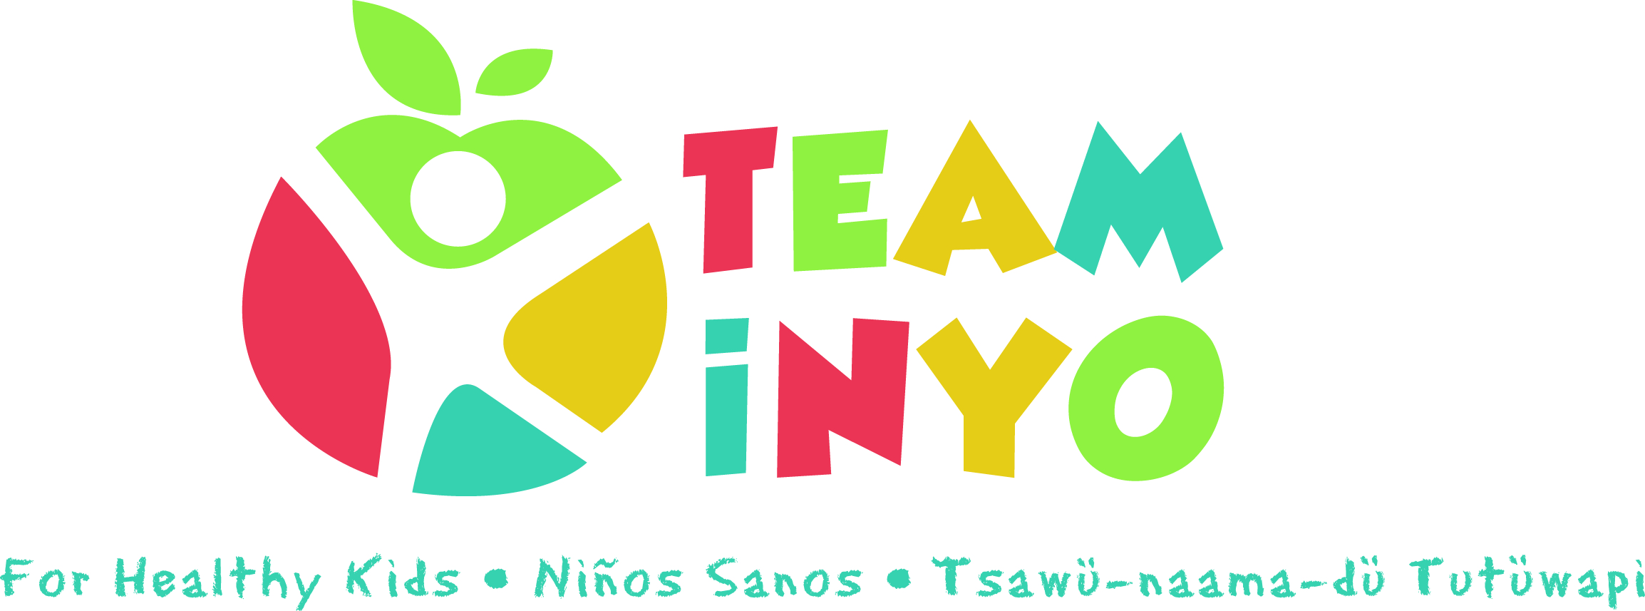
Minutes
July 30th, 2020
Via Zoom
- In attendance: Serena Johnson (First 5), April Eagan (HHS Prevention), Micaela Muro (HHS Prevention), Karen Harrison (Kern Regional), Suzanne Rizo (Child Support Services), Tiara Shoshone (OVCDC), Shannon Beasley (Toiyabe Indian Health Project), Brooke Ross (Community Service Solutions), Leticia Gonzalez (Toiyabe)

- Guest Speaker Julie Faber (Team Inyo for Healthy Kids website designer):
- How to utilize website for virtual outreach events: create registration section
- Suggested to use Strava for competitive activites + see results
- Use “Events” section OR replace “Events” section entirely
- HIPAA controversy: access to medical forms/pdf hand in somewhere? Make sure it’s secure* (applications like Docusign for it and keeping it separate within different organizations)
- Let’s start with one virtual event

- News from the group:
- Leticia Gonzales and Micaela Muro on Facebook event:
- Debriefed mental health awareness run/walk miles challenge in May
- Pretty good participation with ~70 folks in the Facebook “Group” but only ~14 actual sign-ups for participation
- Discussed difficulty navigating the different Facebook features and how it was confusing to create an “Event” for people to follow along.
- Would like to try something similar in the future through the website as a central location and to get more reach there.
- April Eagan and Micaela Muro on the Discovery Tool Trial this month:
a) Met with Ann Banchoff from Stanford to learn about the Our Voice project
- Project and Discovery Tool app used to help communities have a say in how to make their community better
- Helps come to a consensus about an issue in the community to work on
- Team from this meeting will trial it for Free this next month before deciding if we want to purchase for community members to use
- Brooke Ross on Community Service Solutions
- Currently re-branding to CalFresh
- Offering cooking/nutrition activities virtually
- Please follow, like, and share Community Service Solutions on YouTube and Facebook
- April Eagan on Breastfeeding Event:
- Happening tomorrow, August 1st in both Bishop and Lone Pine from 10-12
- Drive-by with precautious COVID19 rules for breastfeeding mothers in community to receive info and goodie bags
- Flyer with detailed info attached in group e-mail
- Serena Johnson update on the NEST:
- Announced the NEST program at NIH no longer being offered so First 5 and partners will be collaborating to offer Pediatrics and NIH support
- Shannon Beasley on Toiyabe Updates:
- Toiyabe services are still being offered with precautions
- Looking at re-evaluating objectives
- Offering emotionally eating presentations
- Dietician services by phone; getting patients in for maintenance
- Talked about the Acorns grant and cancer prevention grant and how to use those now
- Yoga and Zumba offered virtually (attached to group e-mail)
- Suzanne Rizo:
- Offering her 4 tickets to see the outside movie at the Fairgrounds tomorrow, August 1st! E-mail her and reach out to see if available.
- Summer camp with city of bishop going good
- Child Support Awareness month also in August!
- Karen Harrison:
- Kern on monitor list so following their lead
- all distance services; see kids face to face as an option
- Micaela Muro:
- Offered a Spanish Mom’s Nutrition class virtually and hopes to offer another in the Fall in English hopefully with an in-person component if possible
- Officially promoting paid material on the Team Inyo for Healthy Kids Facebook for more page likes and would like to come up with a spreadsheet of designated weeks and/or events to offer partners
- Would like to link more posts to our website; please send material my way!
- *Not mentioned at mtg: offering dental goodie bags to partners mid-August

- Next Meeting Date and Location: Our next meeting will be from 2:15pm to 3:15pm September 3rd via ZOOM.

