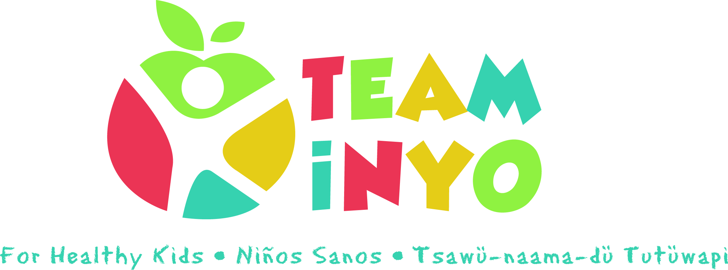
Minutes
June 18th, 2020
Via Zoom
- In attendance: Serena Johnson (First 5), April Eagan (HHS Prevention), Micaela Muro (HHS Prevention), Karen Harrison (Kern Regional), Amy Weurdig (Child Support Services), Ryan Howard (OVCDC), Eryn Clark (Tobacco Control), Shannon Beasley (Toiyabe Indian Health Project), Carrie Brown (Bishop Indian Education Center), Brooke Ross (Community Service Solutions), Gaylene Kinzy (Food Sovereignty Program)

- Guest Speaker Eryn Clark on Inyo County’s proposed Tobacco Retail License (TRL):
- Despite many Federal and State efforts, minors continue to access commercial tobacco and nicotine products with Inyo County youth having one of the highest vaping rates in California. Studies show that 74% of underage youth are getting their tobacco products from a physical location (ie. a retail establishment).
- Inyo County receives limited enforcement from the State; only 2 compliance checks have been conducted in the past 10 years and these show a 31% violation rate!
- A TRL would provide a locally administered mechanism to monitor retailer compliance regarding underage sales and would also provide retailers with educational support and materials.
- TRL’s are an effective evidence based prevention measure and jurisdictions that have TRL’s have shown a 27% decrease in youth sales, a 26% reduction in use and are 55% less likely to report initiation and subsequent use over a 30 day period.
- Despite the fact that there will be no charge for the local TRL, a few retailers have complained that they “don’t want the government in their business.” We have had much support from the public but need more people to show up at the next Board of Supervisor meeting on July 28th to express support! We need you all to please speak up as to how commercial tobacco use has effected the families you work with or even your own families!
- Please stand by for and invitation to attend the BOS zoom meeting on July 28th at 11am!
- Also, the results from the Healthy Stores for Healthy Communities report is out (link and pdf provided in e-mail). A huge thank you to Team Inyo peeps who helped out (Brooke)! https://healthystoreshealthycommunity.com/counties/inyo/

- News from the group:
- Serena Johnson First 5 Update:
- Announced grant approval for Team Inyo for Healthy Kids website expansion to include Family Strengthening portion. It will first start with a Phase 1 to include a resource guide for providers. Phase 2 will be for parents. The website will also be translated into Spanish professionally
- Diaper Depot still operating; call WIC main line at (760)872-1885 to schedule a bin pick-up right outside of the office to maintain social distancing.
- Brooke Ross Snap-Ed Update:
- Working on virtual outreach for nutrition workshops with the schools and available by phone.
- Ryan Howard OVCDC Update:
a) Also offering virtual services and available by phone and online.
- Beginning stages of re-opening; by appointment only and as needed at the beginning of July.
- Gaylene Kinzy FSP Update:
- Also doing virtual outreach like filming gardening tutorials. Gardening at Little Bear Daycare. Online Seed Library still available.
- They have delivered planter boxes and produce to the elders & community.
- Community Market is still on hold.
- Shannon Beasley TIHP:
- Appointments available by phone. There is a translation line for Spanish speakers.
- Had a webinar with BP TANF on Emotional Eating via Webex?
- Toiyabe opening to regular clinic hours this week (6/22)!
- Amy Weirdig CSS:
- Open and can apply online (Fairly already virtual before COVID19; no impact on services really)
- 4-H virtual livestock happening this week (6/22)!
- Master Gardeners has suspended workshops but there is an increase with the gardening hotlines and with food preservers.
- Grand Jury reports out in the next couple of weeks
- April Eagan WIC:
- Services by phone since we have a USDA waiver to not mandate the applicant be there in person; good through September 30th.
- Karen Harrison Kern Regional:
- Offering vendors face-to-face or virtually and getting referrals via Zoom
- Offered Face shields and hand sanitizer to anyone in need; please contact directly.
- Carrie Brown BIEC:
- STREAM 9 week program with weekly bags sent home.
- Many collaborations including Cultural Center and Toiyabe
- Virtual Youth GON 2020
- Virtual TAATSAWANO showcasing numuu regalia video clip deadline June 24th
- Film on tutoring staff
- Mostly providing learning and education and making it fun~ via virtual conferences (UNITY) & Intertribal Summits
- Register for Tribal Prep event beginning this week! (Flyer attached in e-mail)

- Next Meeting Date and Location: Our next meeting will be from 2:15pm to 3:15pm July TBD via Zoom.

