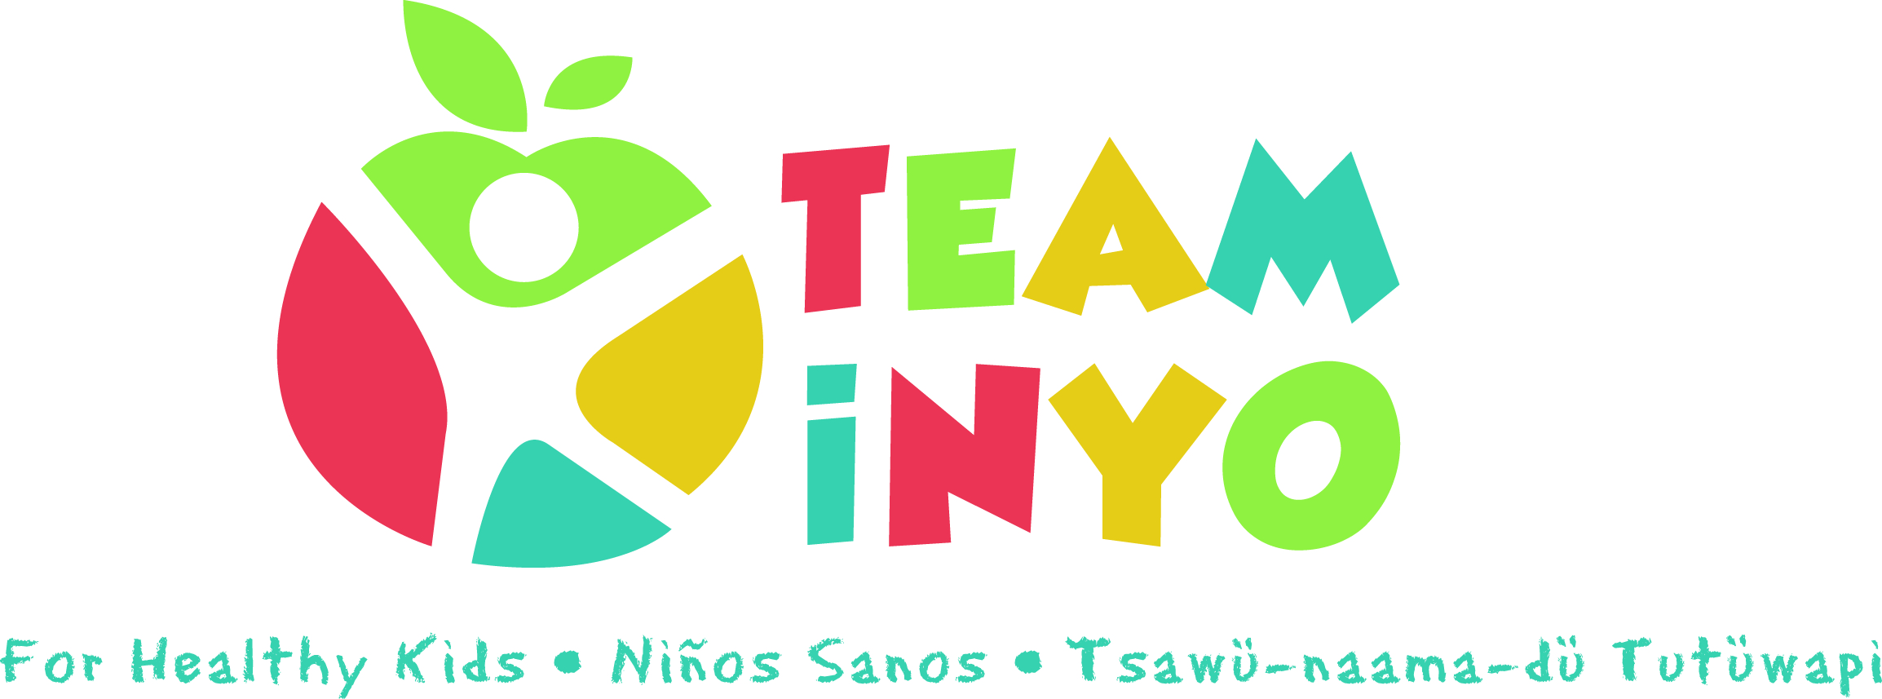
Meeting Agenda
Sept 19th, 2019
3:00-4:30pm
Toiyabe Indian Health Project, TIHP Main Conference Room
- Introductions 3:00 pm
- Eryn Clark – Guest Speaker (10 min)
- Kids Day at the Fair Debrief 3:15 pm
- Goals and Projects for 2019: 3:20 pm
- Serena Johnson – Family Support with Team Inyo
- Walk to School in October – South County?
- Park Rx Program
- https://www.parkrx.org/parkrx-toolkit
- Team Inyo after school events
- Floor decals in schools
- https://www.facebook.com/CharlesCityCSD/videos/290458664920051/
- Resource Flyer/Tree
- Team Inyo Blog Sign Ups!
- September: Ryan Howard and Susanne Rizo
Action Step | Person Responsible | Due Date/Check -in
- October: Heidi Hart

