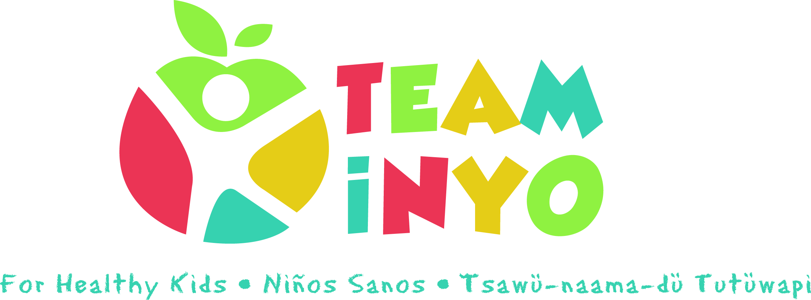
Meeting Agenda
October 17th 2020
3:00-4:30pm
Zoom
- Introductions 10:00 am
- Team Inyo Social Media Outreach Brainstorming 10:15 am
- Wrap-up and Round Table 10:45 am

Action Step | Person Responsible | Due Date/Check -in

