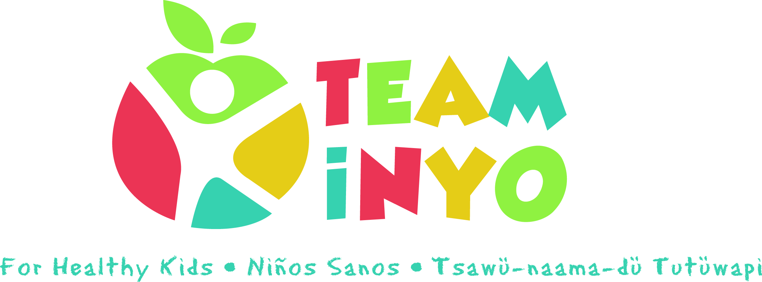
Meeting Agenda
June 18th 2020
2:15 PM
Via Zoom
- Check in – How’s it going? 2:15 pm
- Eryn Clark on TRL 2:30 pm
- May Mental Health Awareness Virtual Walk/Run Challenge 2:45 pm
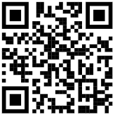
- Goals and Projects: 3:00 pm
-Website
-Park RX
-Our Voice tool
-What’s next?
- Wrap-up/Team Inyo Blog Sign Ups
Action Step | Person Responsible | Due Date/Check -in

