ADVENTURE HUNT

{ } Something colorful

{ } Something smooth

{ } Something rough

{ } Two (2) kinds of leaves

{ } Two (2) kinds of sticks

{ } Something bumpy

{ } A small rock

{ } Something fuzzy

{ } Something Pretty

{ } A flower or petal

{ } A piece of litter/trash

{ } Something you think is a treasure

**OUTDOOR**

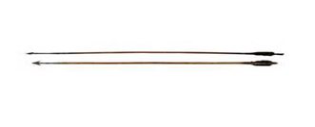[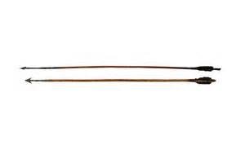](http://www.bing.com/images/search?q=Indian+Arrow+Clip+Art&view=detailv2&&id=1D47607537022AAC22C38C807D8A40E0D38E4FD8&selectedIndex=39&ccid=sIqMJc/i&simid=607987122927632853&thid=JN.HRHkofxFeV3iEt5Sd7%2bqYg)

***Please find things on the ground &***

***Be respectful of Nature***